Erik F Garcia

Project Phase 3

Instructor – Dr. Jessica Lin

Final Report

Video Demo: <https://www.youtube.com/watch?v=kuGnn0Z7nBA>

• Screenshots on program

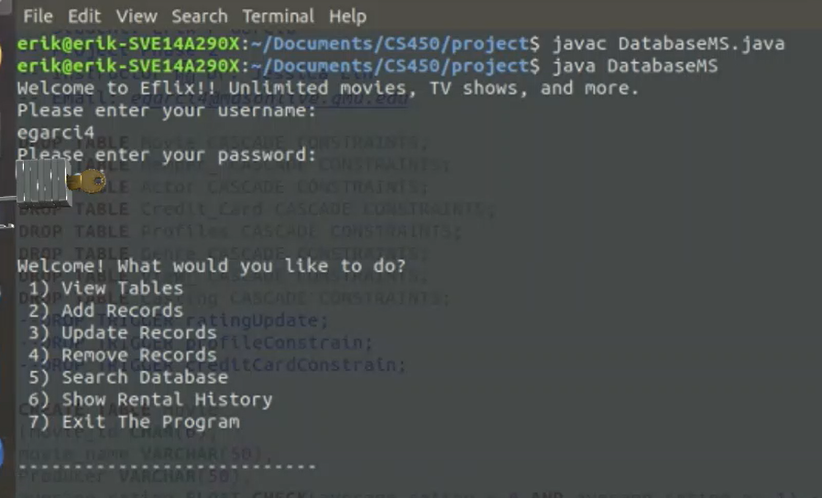

**Phase 1**

The goal of phase 1 was to designed an ED diagram that would satisfied the requirement. There were minor changes made by the end of phase 2.

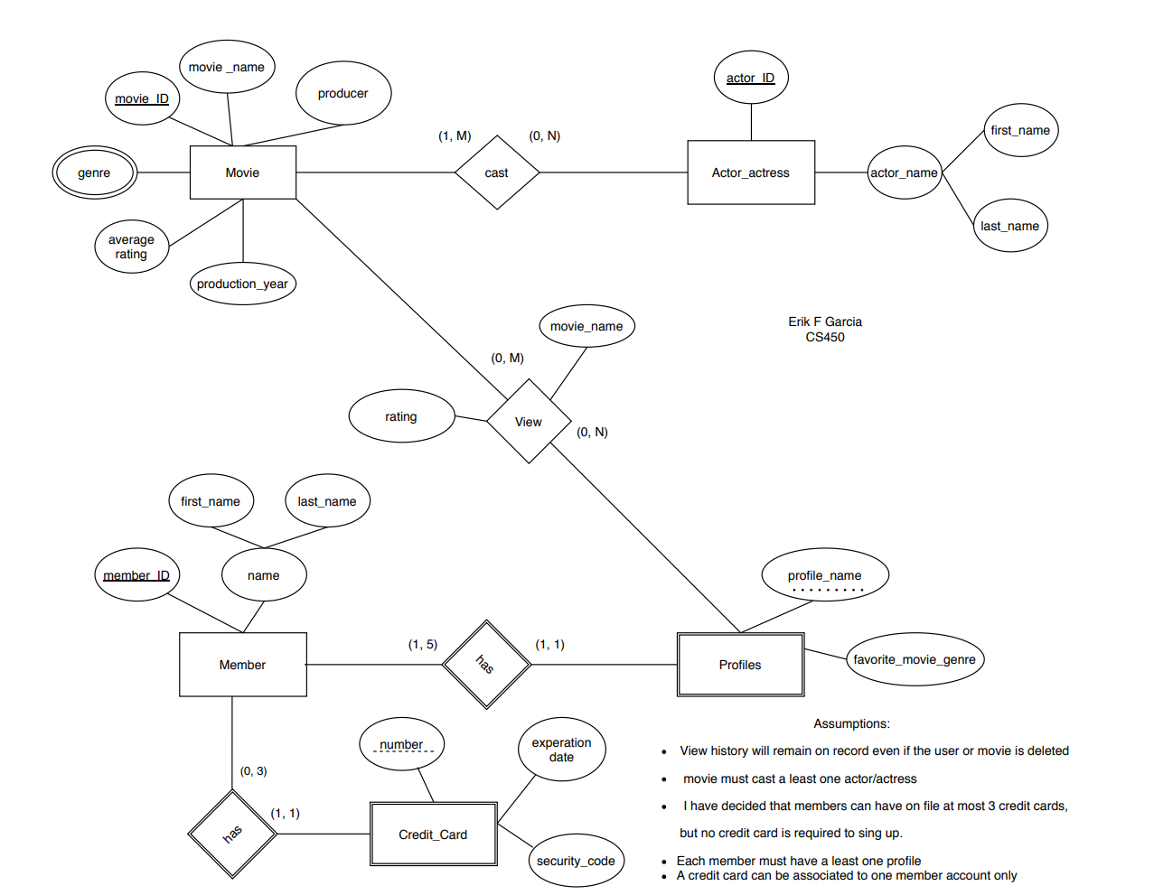

Changes to original ER diagram by phase 2 marked by arrows

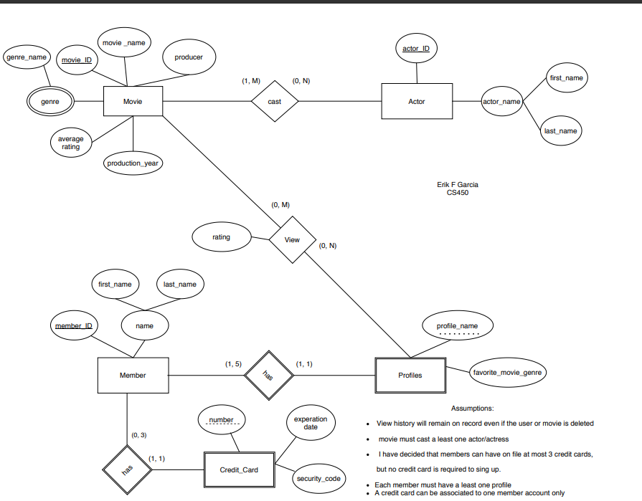

This ER diagram was used for phase 3

**Phase 2**

One of the goals of phase 2 was to translate the ER diagram into relation schema. The following is the relation schema presented for phase 2.

Strong Entities

• Movie(movie_ID, movie_name, producer, average_rating, production_year )

• Member_(member_ID, first_name, last_name)

• Actor(actor_ID, first_name, last_name)

Weak Entities

• Credit_Card(member_ID , number, exp_date, security_code)

Foreign Key : member_ID References Member

• Profiles(member_ID , profile_name, favorite_movie_genre)

Foreign Key : member_ID References Member

• Genre(movie_ID, genre_name)

Foreign Key : movie_ID References Movie

Relations

• View_ (movie_ID, member_ID, profile_name, rating)

Foreign Key: movie_ID references: Movie

Foreign Key: movie_name references: Movie

Foreign Key: member_ID references: Profiles

Foreign Key: profile_name references: Profiles

This schema is **incomplete** because it did not include the relation “Cast”. Therefore, the phase 2 SQL script is also incomplete. This mistake was corrected during phase 3

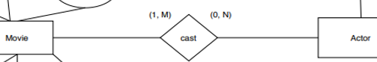

**Phase 3**

During phase 3 “Casting” was aggregated to the relation schema of Phase 2. The SQL script was corrected. Triggers and checks were added to satisfy the constrains.

Strong Entities

* Movie(movie_ID, movie_name, producer, average_rating, production_year )
* Member_(member_ID, first_name, last_name)
* Actor(actor_ID, first_name, last_name)

Weak Entities

* Credit_Card(member_ID , number, exp_date, security_code)

Foreign Key : member_ID References Member

* Profiles(member_ID , profile_name, favorite_movie_genre)

Foreign Key : member_ID References Member

* Genre(movie_ID, genre_name)

Foreign Key : movie_ID References Movie

Relations

* View_ (movie_ID, member_ID, profile_name, rating)

Foreign Key: movie_ID references: Movie

Foreign Key: movie_name references: Movie

Foreign Key: member_ID references: Profiles

Foreign Key: profile_name references: Profiles

* Casting (movie_ID, actor_ID)

Foreign Key: movie_ID references: Movie

Foreign Key: actor_ID references: Actor

Table added to the schema

The following is a fraction of the Script used for this project it shows the creation of table and triggers. The complete script is provided with this report

|  |  |
| --- | --- |
| CREATE TABLE **Movie**  (movie_id CHAR(6),  movie_name VARCHAR(50),  Producer VARCHAR(50),  average_rating FLOAT CHECK(average_rating < 6  AND average_rating >= 1),-- restrict 1-5  production_year INTEGER,  PRIMARY KEY(movie_id)  );  CREATE TABLE **Member_**  (member_id CHAR(6),  first_name VARCHAR(30),  last_name VARCHAR(30),  PRIMARY KEY(member_id)  );  CREATE TABLE **Actor**  (actor_id CHAR(6),  first_name VARCHAR(50),  last_name VARCHAR(50),  PRIMARY KEY(actor_id)  );  CREATE TABLE **Credit_Card**  (member_id CHAR(6),  number_ VARCHAR(16),  exp_date DATE,  security_code CHAR(4),  PRIMARY KEY(member_id, number_),  FOREIGN KEY(member_id)REFERENCES Member_ ON DELETE CASCADE  );  CREATE TRIGGER **creditCardConstrain**  BEFORE INSERT ON Credit_Card  FOR EACH ROW  DECLARE  creditCardNum INTEGER;  Too_many EXCEPTION;  BEGIN  SELECT COUNT(*) INTO creditCardNum  FROM Credit_Card  WHERE member_id = :NEW.member_id;  IF creditCardNum > 2 THEN  RAISE Too_many;  END IF;  EXCEPTION  WHEN Too_many THEN  RAISE_APPLICATION_ERROR(-20000, 'You can have up to 3 credit cards on file!');  END creditCardConstrain;  /  CREATE OR REPLACE TRIGGER **ratingUpdate**  FOR INSERT ON View_ COMPOUND TRIGGER  newRating FLOAT;  m_id CHAR(6);  BEFORE EACH ROW IS  BEGIN  m_id := :NEW.movie_id;  END BEFORE EACH ROW;  AFTER STATEMENT IS  BEGIN  SELECT AVG(rating)INTO newRating  FROM View_  WHERE movie_id = m_id;  UPDATE Movie  SET average_rating = newRating  WHERE movie_id = m_id;  END AFTER STATEMENT;  END ratingUpdate;  / | CREATE TABLE **Profiles**  (member_id CHAR(6),  profile_name VARCHAR(50),  favorite_movie_genre VARCHAR(50),  PRIMARY KEY(member_id, profile_name),  FOREIGN KEY(member_id)REFERENCES member_ ON DELETE CASCADE  );  CREATE TRIGGER **profileConstrain**  BEFORE INSERT ON Profiles  FOR EACH ROW  DECLARE  profileNum INTEGER;  Too_many EXCEPTION;  BEGIN  SELECT COUNT(*) INTO profileNum  FROM Profiles  WHERE member_id = :NEW.member_id;  IF profilenum > 4 THEN  RAISE Too_many;  END IF;  EXCEPTION  WHEN Too_many THEN  RAISE_APPLICATION_ERROR(-20000, 'You can have up to 5 profiles!');  END profileConstrain;  /  CREATE TABLE **Genre**  (movie_id CHAR(6),  genre_name VARCHAR(50),  PRIMARY KEY(movie_id, genre_name),  FOREIGN KEY(movie_id)REFERENCES Movie ON DELETE CASCADE  );  CREATE TABLE **View_**  (movie_id CHAR(6),  member_id CHAR(6),  profile_name VARCHAR(50),  rating FLOAT CHECK(rating < 6 AND rating >= 1),  PRIMARY KEY(movie_id, member_id, profile_name),  FOREIGN KEY(movie_id) REFERENCES Movie,  FOREIGN KEY (member_id, profile_name) REFERENCES Profiles  );  CREATE TABLE **Casting**  (movie_id CHAR(6),  actor_id CHAR(6),  PRIMARY KEY(movie_id, actor_id),  FOREIGN KEY(movie_id) REFERENCES Movie,  FOREIGN KEY (actor_id) REFERENCES Actor  ); |

**JDBC Implementation**

This database management systema software is designed to define, manipulate, retrieve, and manage data on all relations based on the project requirement. The design resembles the suggested schema on the instruction, but it is not 100% similar.

All parts work as intended based on my understanding of the requirements. However, there is room for improvement. For example when listing table content the application does not list the columns title and more user input validation is necessary. Extra features such as search movie by genre would also complement this application.

Please read README.txt for description on how to run the program.

**Contributions:**

This project was 100% designed and implemented by Erik F Garcia